Download and install **PYTHON**

<https://www.python.org/downloads/windows/>

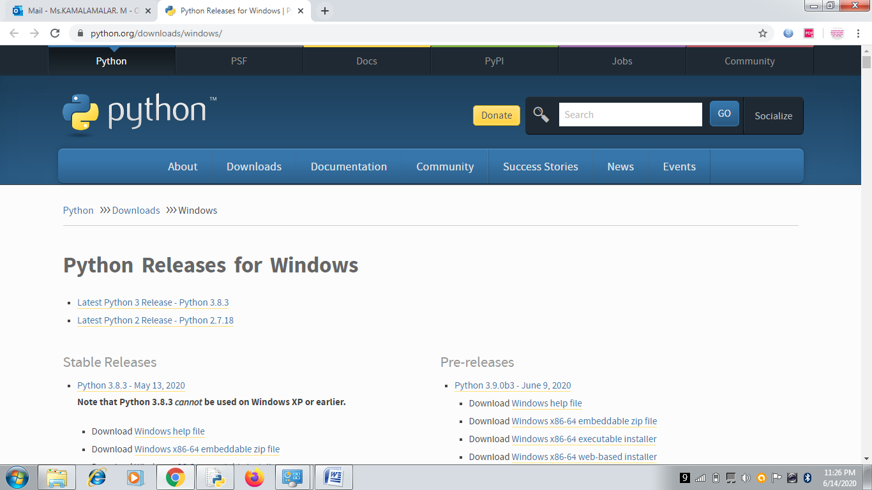

[Python 3.6.4rc1 - Dec. 5, 2017](https://www.python.org/downloads/release/python-364rc1/)

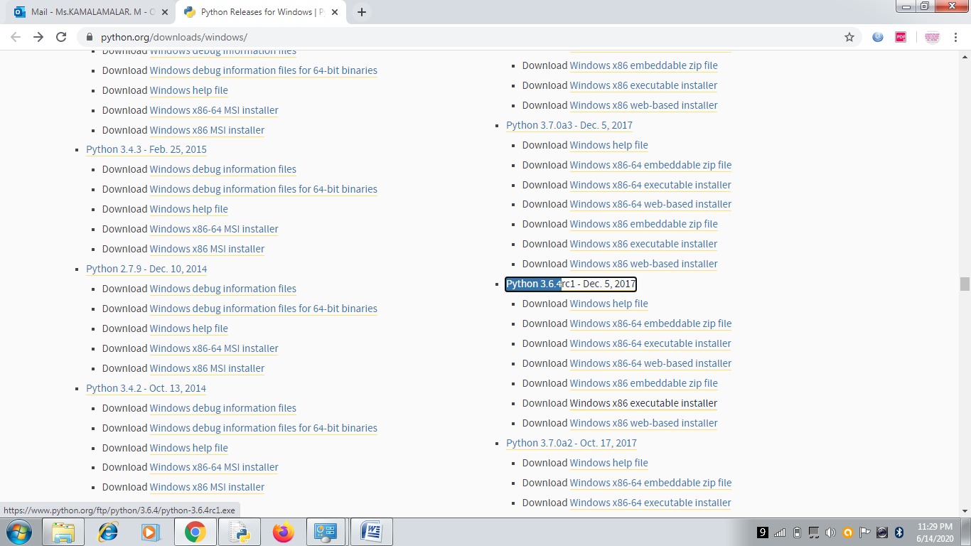

Download [Windows x86-64 executable installer](https://www.python.org/ftp/python/3.6.4/python-3.6.4rc1-amd64.exe)

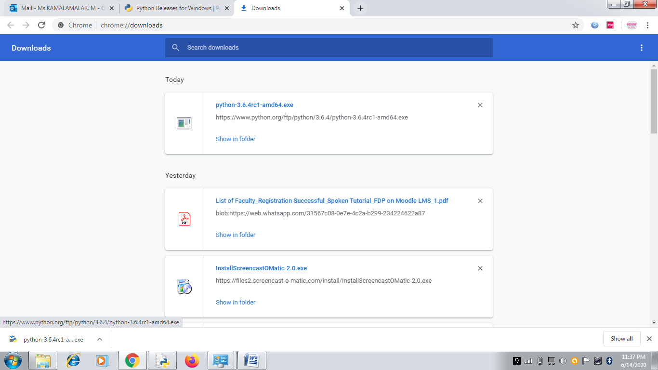

Click the exe file and run (double click)

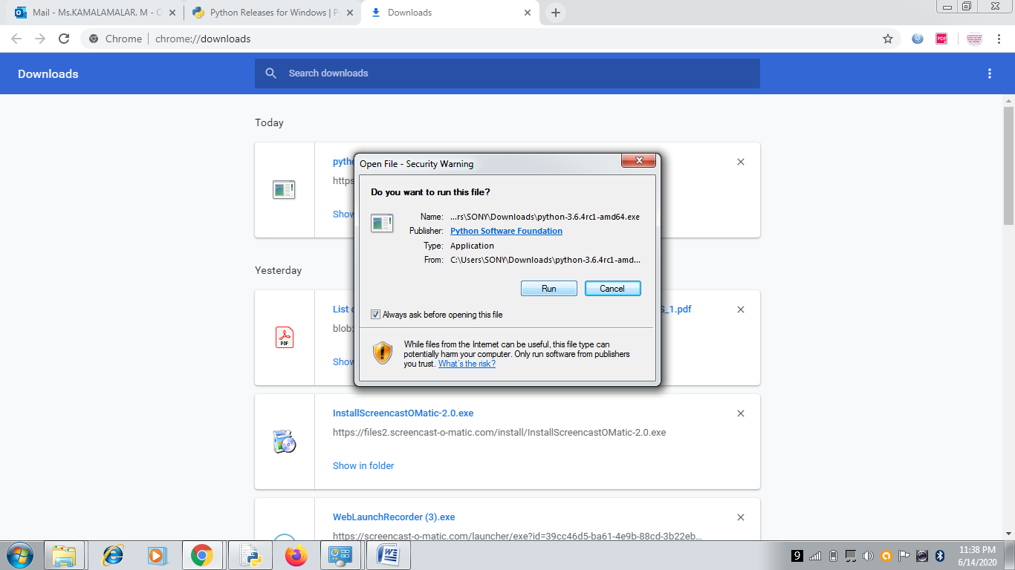

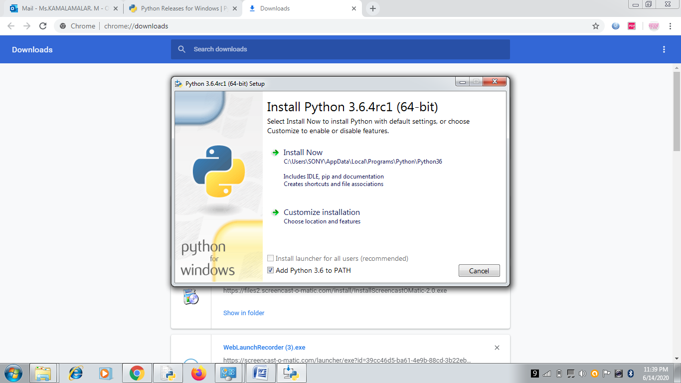

Click install now

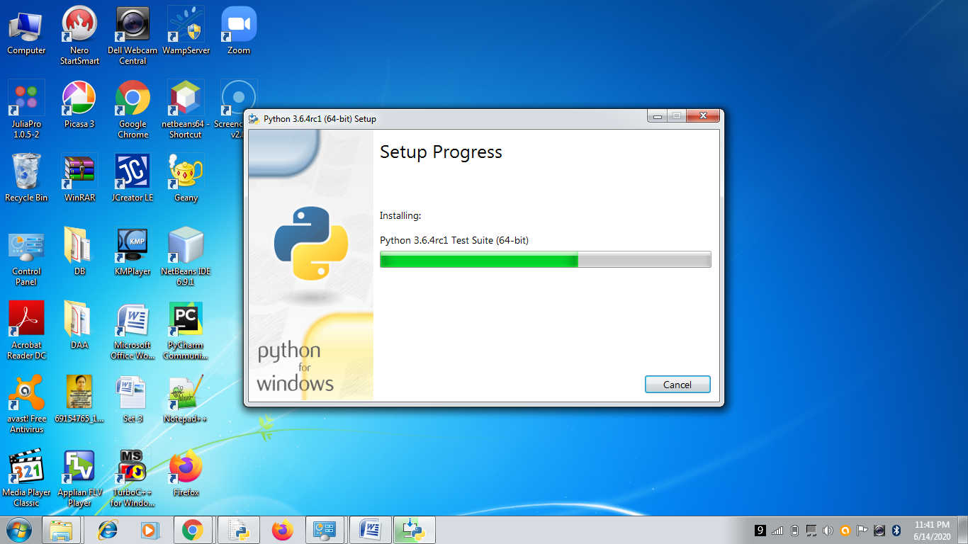

Python Installed, Click Close button.

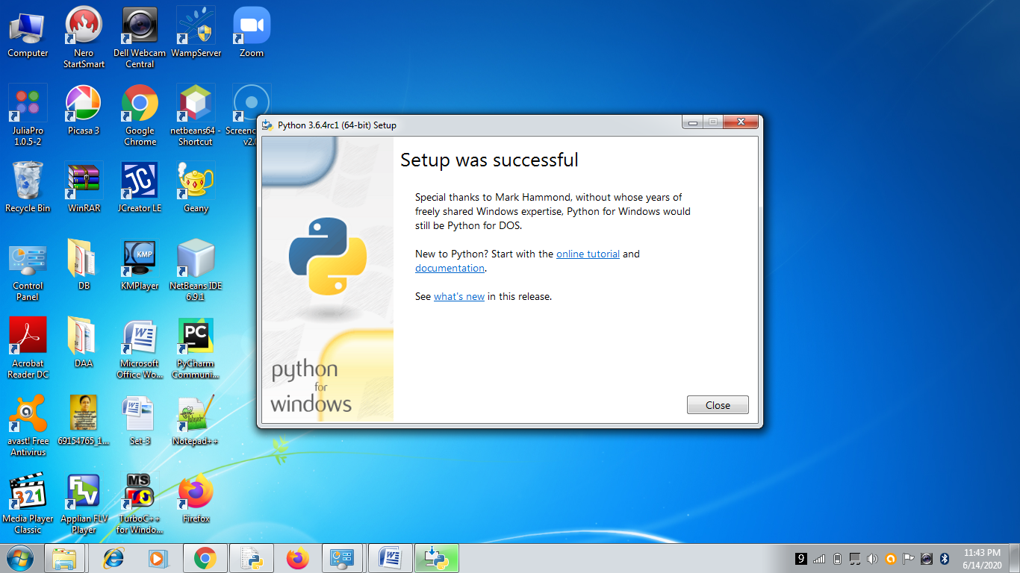

Start ->All Program->Python 3.6-> Click IDLE( Python 3.6 64 bit)

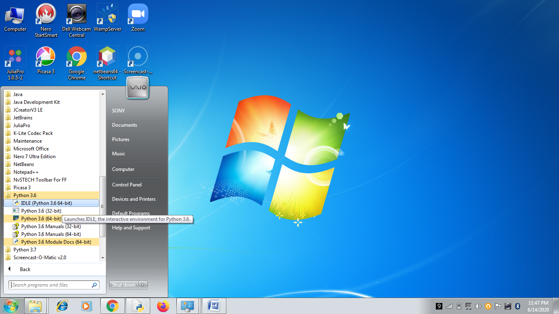

IDE opens

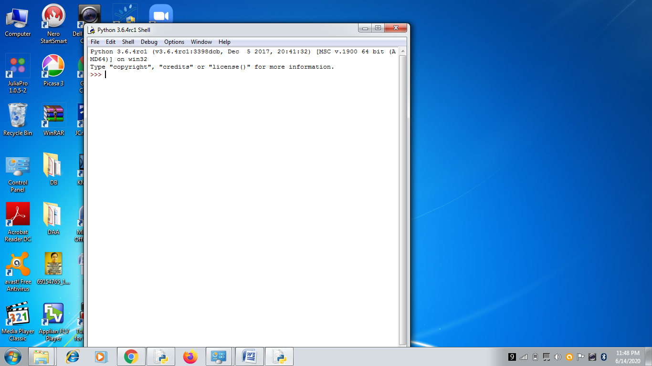

U R Ready to Work with Python

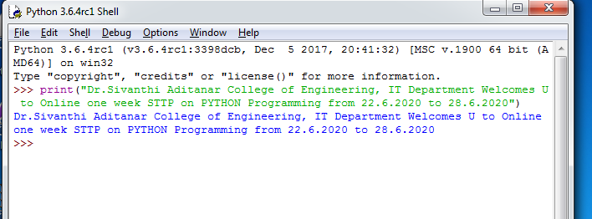

Note:

[Latest Python 3 Release - Python 3.8.3](https://www.python.org/downloads/release/python-383/)